by m.malathi

order processing

#### **Order Processing**

1. Apr 01 Purchase order issued to M/s. COMPAQ SYSTEM LTD for the followings

* 70GB Ram 700nos @ Rs.2000each
* 50Gb Hard disk drive 500nos @ Rs.3000each
* CPU 100nos @ Rs.5000each Order No:CS82

2. Apr08 Stock received from M/s. COMPAQ SYSTEM LTD for the followings

* 70GB Ram 600nos @ Rs.2000each
* 50Gb Hard disk drive 450nos @ Rs.3000each
* CPU 100nos @ Rs.5000each Against Order No: CS82 bill no: 45 (45days)

3. Apr15 Sales order received from M/s. MORDEN COMPUTERS for the followings

* 70GB Ram 500nos @ Rs.2500each
* 50Gb Hard disk drive 450nos @ Rs.3500each
* CPU 80nos @ Rs.6000each Order No:MC55

4. Apr 20 Stock issued to M/s. MORDEN COMPUTERS for the followings

* 70GB Ram 450nos @ Rs.2500each
* 50Gb Hard disk drive 400nos @ Rs.3500each
* CPU 60nos @ Rs.6000each Against Order No: MC55 bill no: 564 (30days)
* 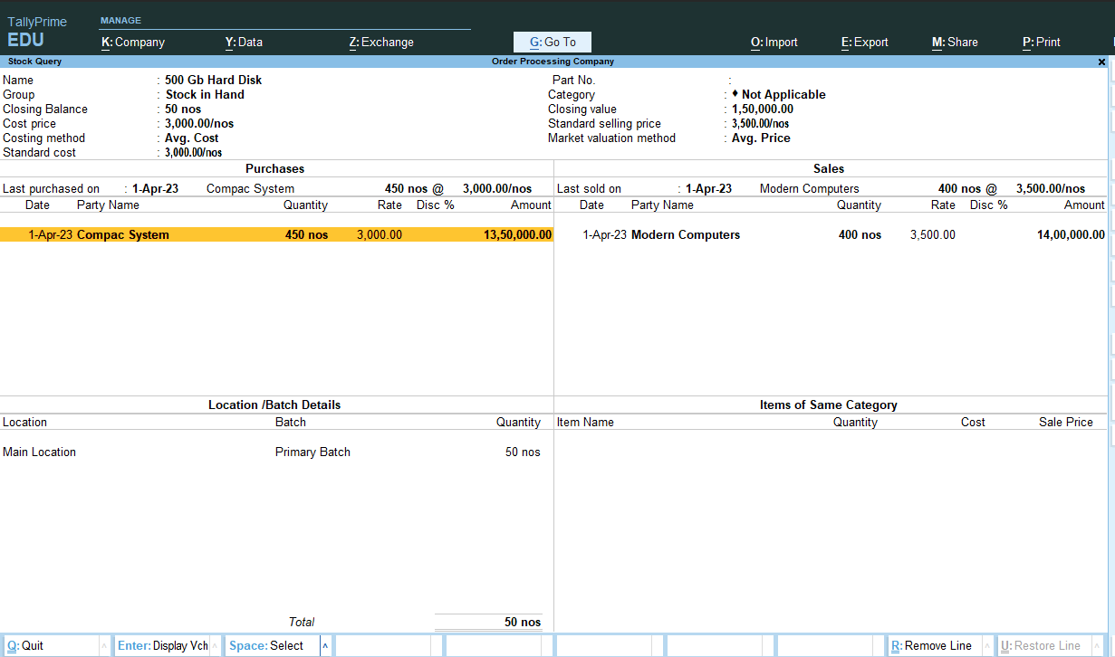
* 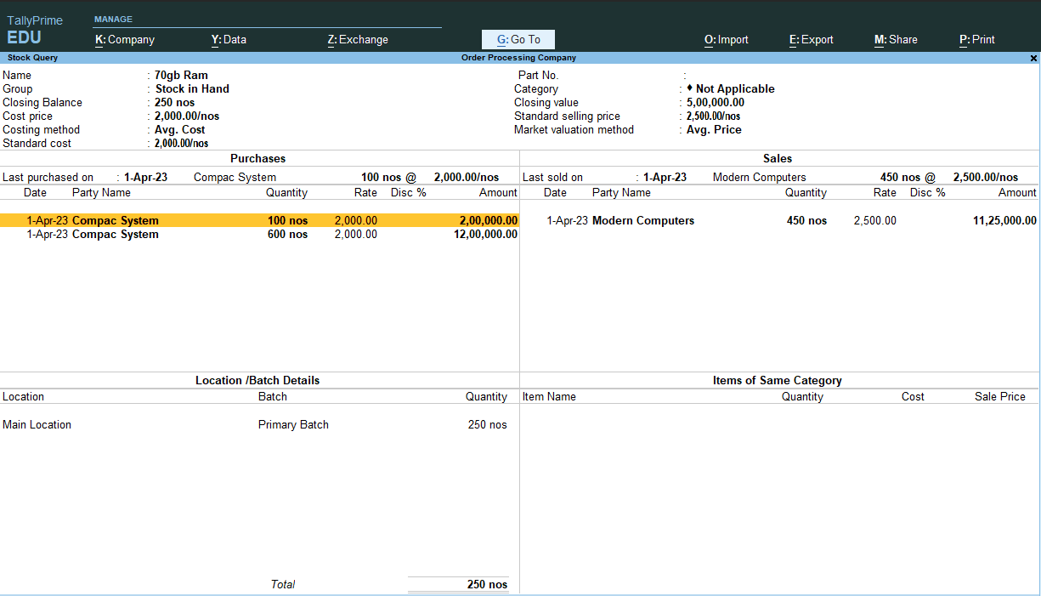

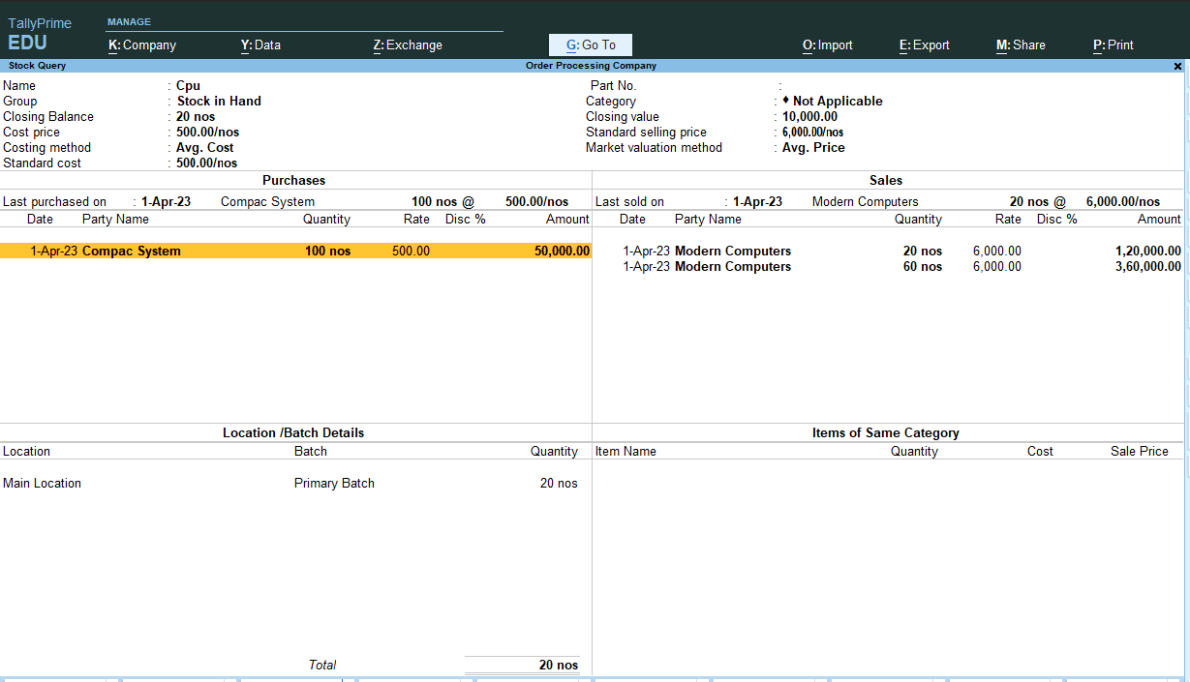

ORDER PROCESS PROJECT COMPLETED